**Exercise NO 7: Use Google and Whois for Reconnaisasance.**

Aim:

To find out the Whois, DNS Records and Diagonstics for particular website by using Whois search.

Procedure:

Step1: Open the WHO.is website

Step 2: Enter the website name in search bar and hit the “Enter button”.

Step 3: Show you information about [www.saveetha.com](http://www.saveetha.com/)

Output:

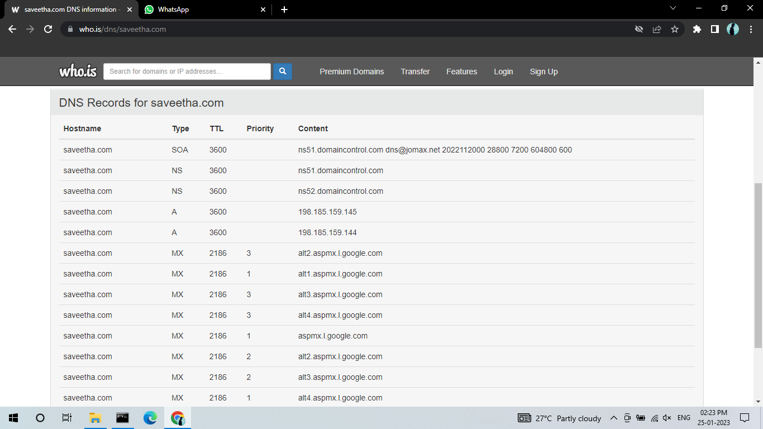

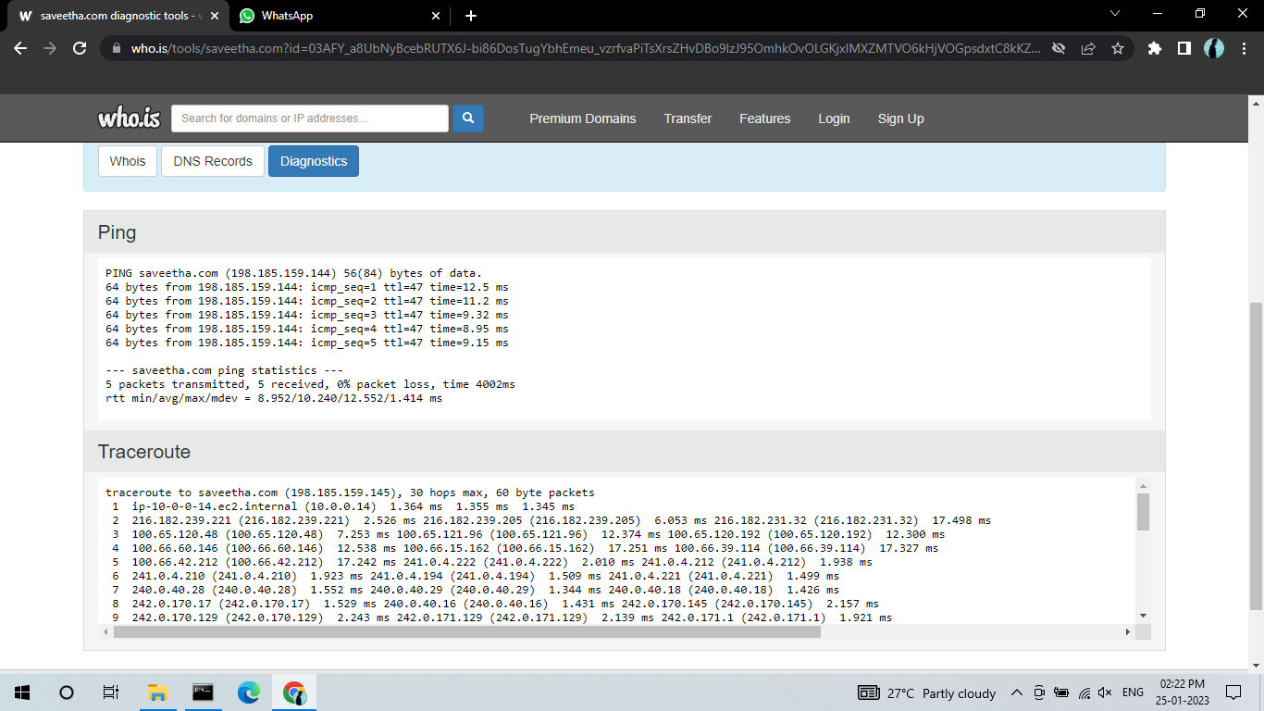

**Result:**

Thus, DNS Records and Diagnostics for particular website has been found using Whois and Google.